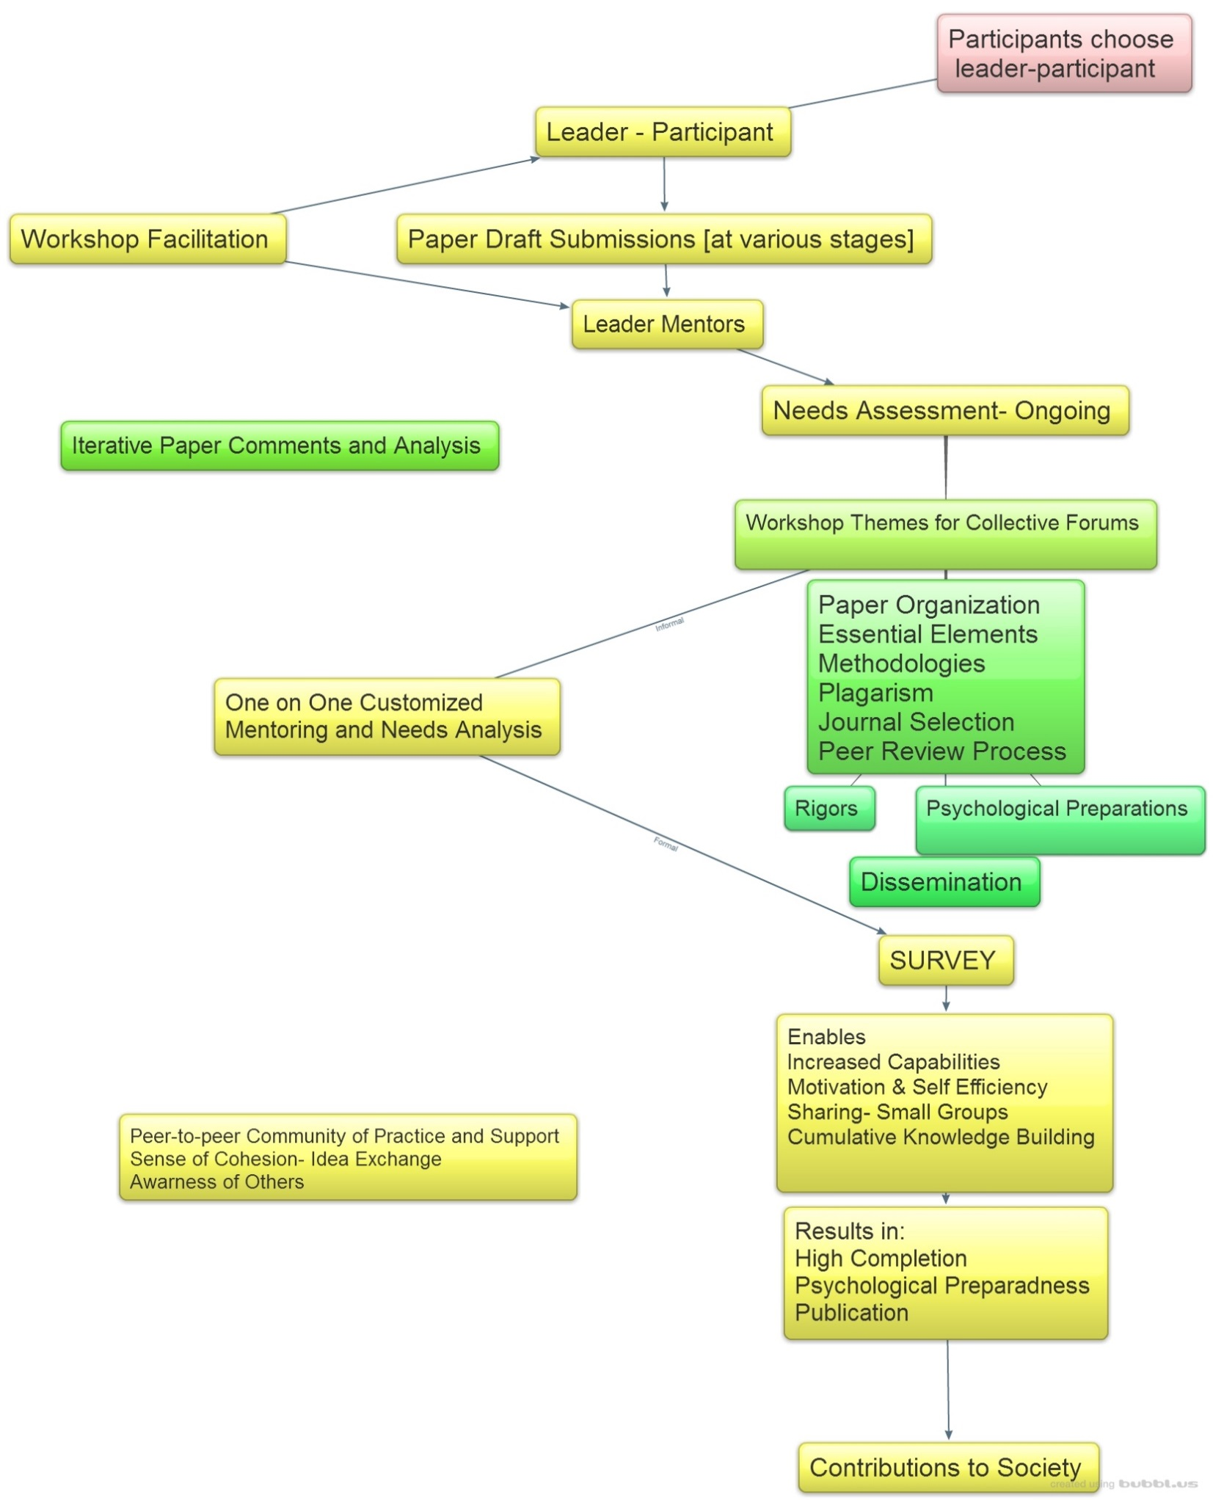
.
Figure 1: Innovation in designing and conducting writing retreats for academic staff in higher education
[The figure illustrates the features of the June 2016 writing retreat discussed in this article].
Format used to generate Figure: Windows Photo Viewer
Innovation in designing and conducting writing retreats for academic staff in higher education”
University or College Community of Practice

