

13 June 2018

TO WHOM IT MAY CONCERN

I, the undersigned, hereby declare that the journal article titled A meta-reflection on my emerging as a scholar of action research by Pieter H du Toit has been edited.

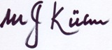

Prof. Tinus Kühn

